EXPT NO:2 | Implementation of data visualization techniques
DATE: 06.01.2026 | Implementation of data visualization techniques

PRE-LAB QUESTIONS (PROVIDE BRIEF ANSWERS TO THE FOLLOWING QUESTIONS)
- Why is exploratory data analysis critical before model building?
Exploratory Data Analysis is critical because it helps us to identify missing values, detect anomalies, and understand the underlying structure of the data before we feed it into an algorithm. If EDA is skipped, a model learns from noise rather than actual patterns.
- How do distributions influence algorithm selection in ML?
The shape of the data tells what algorithm should be used. Many algorithms like Linear Regression or Gaussian Naive Bayes assume data follows a normal (bell curve) distribution. If the data is highly skewed or non-linear, we might need to choose non-parametric algorithms (like Decision Trees) or apply transformations to the data first.
- What insights can outliers provide in business data?
Outliers highlight deviations from normal behaviour, which helps businesses detect critical anomalies like fraudulent transactions, operational errors, or unique opportunities like high-value customer spending that require special attention.
- Why are visual summaries preferred over raw tables?
Visual summaries are preferred because they allow humans to instantly recognize trends, patterns, and relationships like seasonality or correlations that are difficult and time-consuming to spot when scanning rows of raw numbers and tables.
- How does visualization improve business intelligence?
Visualization turns static metrics into actionable stories. It improves business intelligence by allowing non-technical decision-makers to grasp complex insights quickly. This leads to faster decision-making, such as identifying a sudden drop in sales or spotting a rising product category in real-time.

IN-LAB EXERCISE:

OBJECTIVE:

To explore data distribution and variability using advanced visualization techniques.

SCENARIO:
A startup analyses e-commerce transaction data to understand customer spending behaviour and detect abnormal purchase patterns.

IN-LAB TASKS (Using R Language)
- Plot histogram of transaction amounts
- Use boxplot to detect outliers
- Create heatmap of monthly sales intensity
Code:

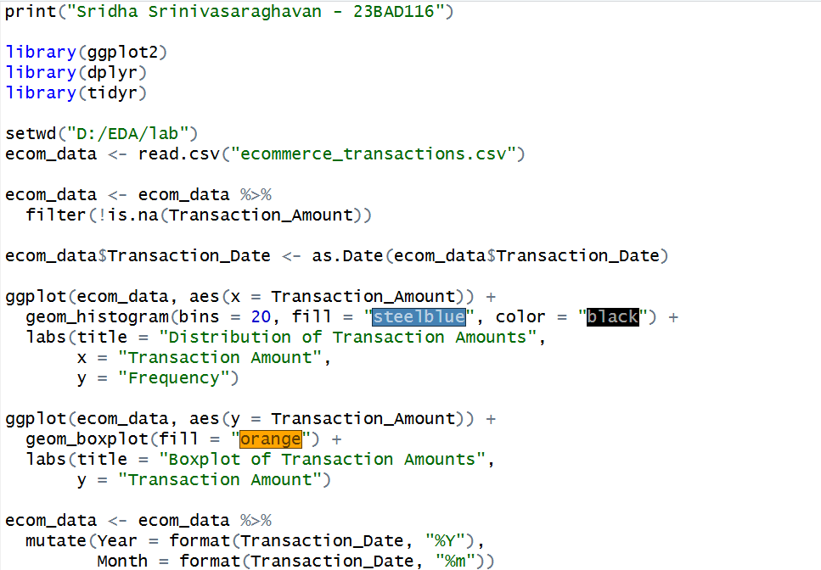

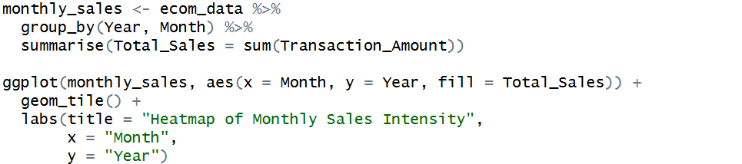

Output:

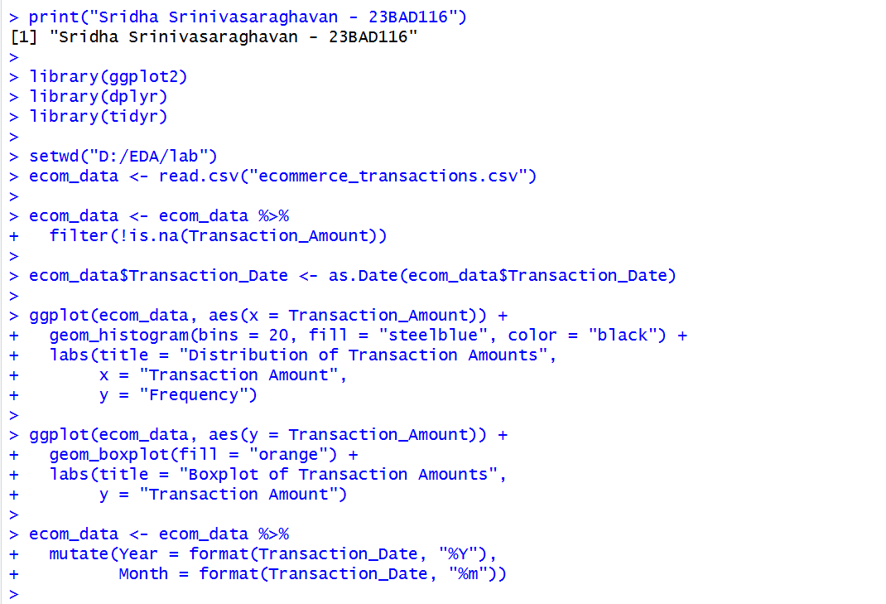
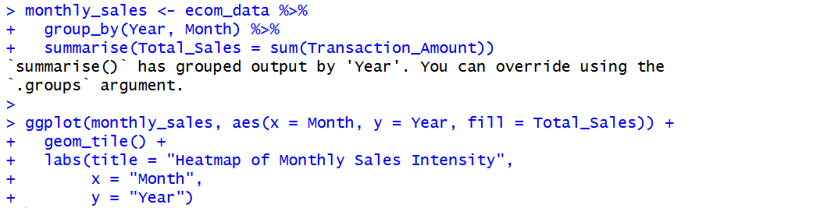

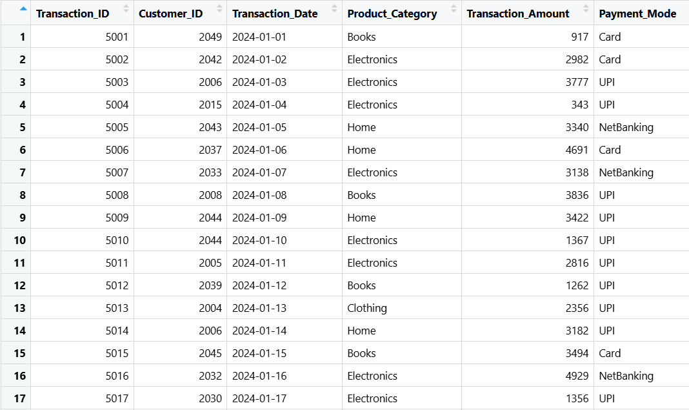

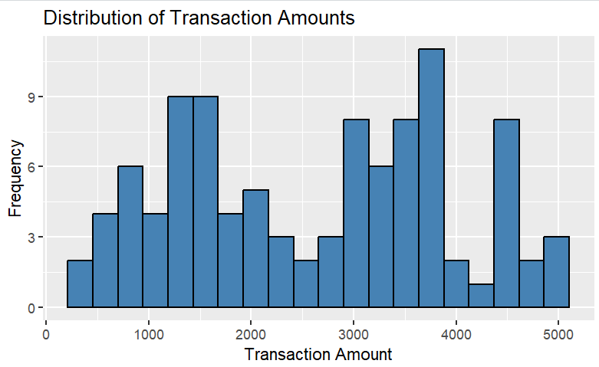

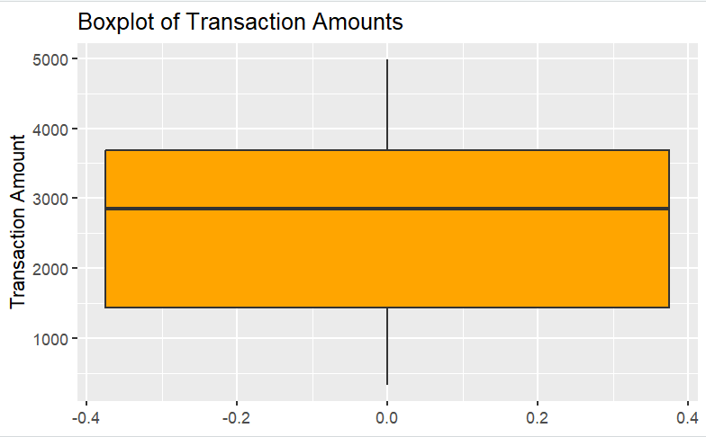

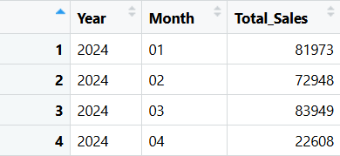

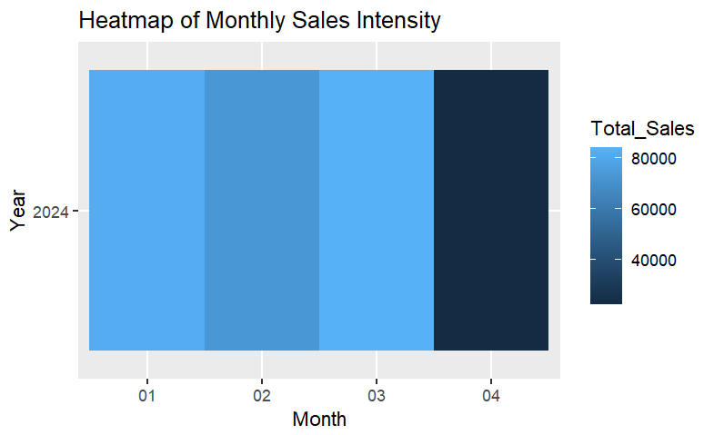
POST-LAB QUESTIONS (PROVIDE BRIEF ANSWERS TO THE FOLLOWING QUESTIONS)

- What does right-skewed distribution indicate about customer behaviour?

A right-skewed distribution indicates that most customers make low to moderate purchases, while a small number of customers make very high-value transactions. This suggests the presence of premium or bulk buyers.

- How can detected outliers impact business decisions?

Outliers may represent fraud, data errors, or high-value customers. Identifying them helps businesses take informed actions such as fraud prevention, targeted marketing, or personalized customer engagement.

- Which visualization best supports anomaly detection?

Boxplots are most effective for anomaly detection as they clearly highlight outliers beyond the normal data range using whiskers and isolated points.

- How does EDA improve AI model accuracy?

Exploratory Data Analysis helps identify data inconsistencies, outliers, and important patterns, enabling proper preprocessing and feature selection, which improves AI model accuracy and reliability.

- How can visualization guide feature engineering?

Visualization reveals relationships, trends, and distributions in data, helping engineers create meaningful features such as aggregations, transformations, and categorical groupings that enhance model performance.

ASSESSMENT
Description | Max Marks | Marks Awarded
Pre Lab Exercise | 5
In Lab Exercise | 10
Post Lab Exercise | 5
Viva | 10
Total | 30
Faculty Signature

